1. Create a database named employee, then import **data_science_team.csv** **proj_table.csv** and **emp_record_table.csv** into the **employee**database from the given resources.

Created a database named employee, then imported data_science_team.csv proj_table.csv and emp_record_table.csv into the employee database

1. Create an ER diagram for the given employee database.
2. Write a query to fetch EMP_ID, FIRST_NAME, LAST_NAME, GENDER, and DEPARTMENT from the employee record table, and make a list of employees and details of their department.

Ans.: Query: select emp_ID, first_name, last_name, GENDER, dept from employee.emp_record_table;

|  |  |  |  |  |  |
| --- | --- | --- | --- | --- | --- |
|  | **emp_ID** | **first_name** | **last_name** | **GENDER** | **dept** |
|  | E001 | Arthur | Black | M | ALL |
|  | E005 | Eric | Hoffman | M | FINANCE |
|  | E010 | William | Butler | M | AUTOMOTIVE |
|  | E052 | Dianna | Wilson | F | HEALTHCARE |
|  | E057 | Dorothy | Wilson | F | HEALTHCARE |
|  | E083 | Patrick | Voltz | M | HEALTHCARE |
|  | E103 | Emily | Grove | F | FINANCE |
|  | E204 | Karene | Nowak | F | AUTOMOTIVE |
|  | E245 | Nian | Zhen | M | RETAIL |
|  | E260 | Roy | Collins | M | RETAIL |
|  | E403 | Steve | Hoffman | M | FINANCE |
|  | E428 | Pete | Allen | M | AUTOMOTIVE |
|  | E478 | David | Smith | M | RETAIL |
|  | E505 | Chad | Wilson | M | HEALTHCARE |
|  | E532 | Claire | Brennan | F | AUTOMOTIVE |
|  | E583 | Janet | Hale | F | RETAIL |
|  | E612 | Tracy | Norris | F | RETAIL |
|  | E620 | Katrina | Allen | F | RETAIL |
|  | E640 | Jenifer | Jhones | F | RETAIL |

1. Write a query to fetch EMP_ID, FIRST_NAME, LAST_NAME, GENDER, DEPARTMENT, and EMP_RATING if the EMP_RATING is:
   1. less than two

Ans.: select emp_ID, first_name, last_name, GENDER, dept, EMP_RATING from employee.emp_record_table where (emp_rating<2);

Data after filtering employee rating less than 2.

* 1. greater than four

Ans.: select emp_ID, first_name, last_name, GENDER, dept, EMP_RATING from employee.emp_record_table where (emp_rating>4);

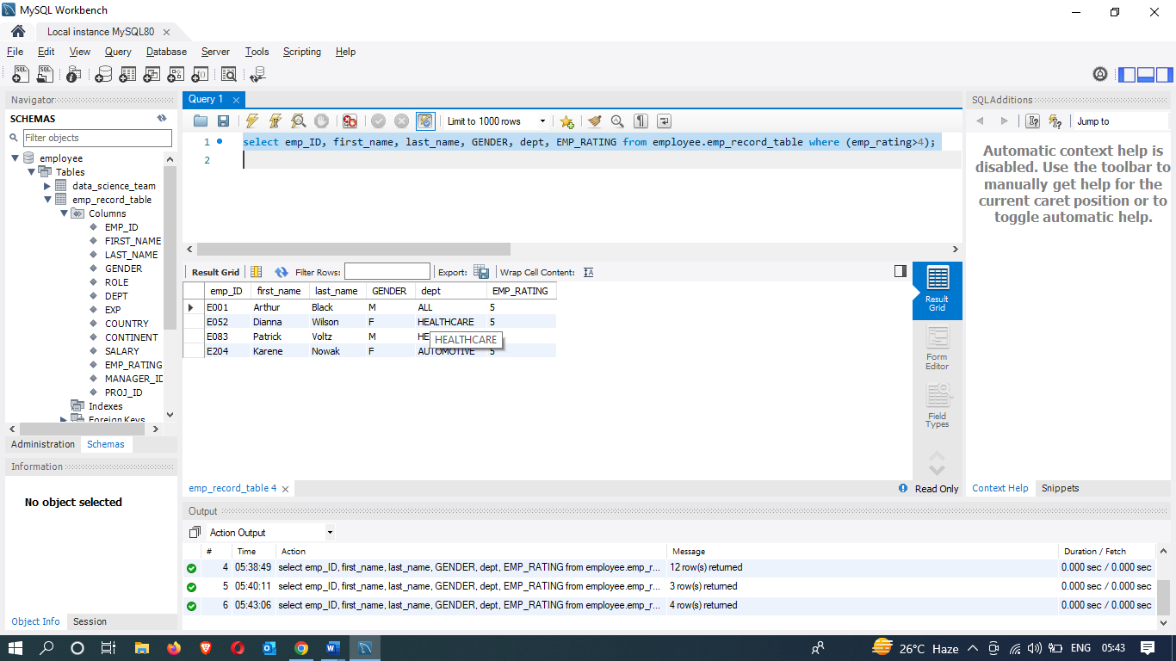

* 1. between two and four

Ans.: select emp_ID, first_name, last_name, GENDER, dept, EMP_RATING from employee.emp_record_table where (emp_rating>2 and emp_rating<4);

1. Write a query to list only those employees who have someone reporting to them. Also, show the number of reporters (including the President).

Ans.:

1. Write a query to list down all the employees from the healthcare and finance departments using union. Take data from the employee record table.
2. Write a query to list down employee details such as EMP_ID, FIRST_NAME, LAST_NAME, ROLE, DEPARTMENT, and EMP_RATING grouped by dept. Also include the respective employee rating along with the max emp rating for the department.